No. of Pages | 3
No. of Questions | 4

Department of Computer Science and Engineering
MIDTERM EXAMINATION SUMMER 2010

CSE320: Data Communications
Total Marks: 60 Time Allowed: 70 minutes

- Answer ALL Four (4) questions.
- Figure in bracket [] next to each question indicates marks for that question.

Question No. 1

- Match the following to one or more layers of the OSI model [3 marks]
    - Conversion of binary to electrical signals
    - Compression of Audio and Video files
    - Fragmenting PDU further as the media is unable to carry the PDU size.
    - Decides the ways in which devices can be connected to form a topology.
    - Resends PDUs if they are lost in transmission.
    - Do not create any connections with the receiver before sending data.
- What does TCP/IP stand for? Compare it with the OSI model. [3 marks]
- Compare and contrast segments, packets and frames.(3 points) [4.5 marks]
- Complete the frames (1,2 &3) shown below with appropriate port, IP and MAC addresses (Use the separate sheet provided). The sender Host A has two applications running; one for email with port number of 1030 and the other for accessing the web server with port number 1033. The frames shown are all intended for the web server. (For indicating MAC addresses just mention the device or device interface) [4.5 marks]
Frame 3
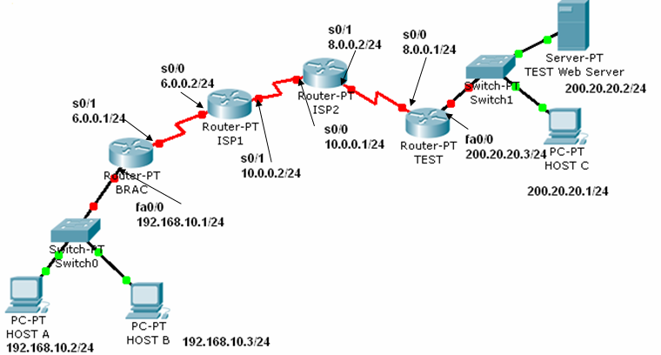
Figure No. 1
Email
Web Browser
Frame 1
Frame 2

Question No. 2

- IP is an unreliable and connectionless protocol. Why was IP designed with these characteristics? [3 marks]
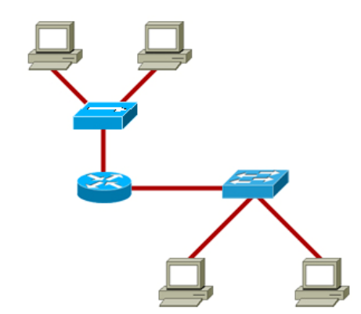
Figure No. 2

- What is a broadcast, and what is a broadcast domain? In the figure no. how many broadcast domains exist? [3 marks]

Gateway of last resort is 172.16.2.2 to network 0.0.0.0
R 195.10.10.0/24 [120/2] via 172.16.1.2,00:00:02, serial0/0
R 200.20.20.0/24 [120/3] via 172.16.2.2,00:00:10, serial0/1
C 172.16.1.0/24 is directly connected, serial 0/0
C 172.16.2.0/24 is directly connected, serial 0/1
C 172.16.4.0/24 is directly connected, FastEthernet0/0
S 200.20.30.0/24 [1/0] via 172.16.4.1
S* 0.0.0.0/0 [1/0] via 172.16.2.2

Figure No. 3

- The above figure no. 3 represents the routing table of a router. What does the routes S and S* represent? How are they different from the ‘R’ routes? [4 marks]
- Two packets arrive at the router, one has the destination IP address of 200.20.30.24/24 and the other has the destination IP address of 195.10.10.6/24. Using the figure no. 3 above, what will the router do? Through which interfaces will the router send these two packets? [4 marks]
- How many interfaces does the router of figure no. 3 have? [1 mark]

Question No. 3

- What types of messages are used in HTTP? Explain them briefly. [ 3 marks]
- When you write www.games.com in the URL of a web browser, the first packet sent by your PC is to your local DNS server. But your local DNS server does not have the IP address to that URL. Will you be able to go that website? Yes or no, explain your answer. [Assume that there is no problem with the website] [4 marks]
- Which protocol helps us access the Internet without any configuration hassle while drinking coffee at a coffee shop? How does the protocol help? [3 marks]
- Draw a diagram showing where SMTP and POP are used for sending and receiving emails. [3 marks]
- What is SMB used for? [2 marks]

Question No. 4

  - UDP has no sequence number and acknowledgement number in its header, why? [3 marks]
  - Host A sends data using TCP to host B; it has negotiated a window size of 2000 bytes. It creates segments of 600 bytes each. The first data starts from 501st byte. How many segments can host A send? What are the sequence numbers for each of the segment? [4 marks]
  - A web server receives two web page requests from two different clients. As the clients chose their port number randomly, both client ports numbers are same which is 49,152. How will the server differentiate between the two different clients, when it replies? What kind of port number does the server use? [5 marks]
  - Host A wants to close its connection with host B. What will it do? [3 marks]

THE END

